Stock Production Models

Stock production models are summarised by:

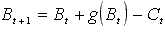
where is the population biomass at start of time interval t, is the total catch during time interval t and 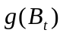 is represented by one of three models

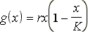 | Schaefer model
 | Fox model
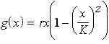

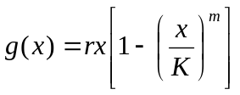

PellaTomlinson model
Where K is the carrying capacity of the population,
r is the intrinsic rate of growth and
m is the shape parameter of the PellaTomlinson production function.

Timing
Both the indexed recruitment models and the stock production models are formulated in discrete time and assume that the expected abundance index will be given by:
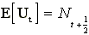 | Indexed recruitment models
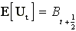 | Production models
where for production models,
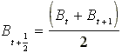
Error models
The equations given below use population size in numbers, N. To obtain the error models for production models, simply replace N by B. The equations also assume that catch per unit effort (CPUE) is used as the abundance index. If an alternative relative abundance index, , is used in place of CPUE data from then the terms for catch taken by effort , , and effort, , should be replaced by and 1, respectively.
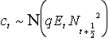 | Normal
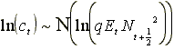 | Log-Normal
where q is the catchability coefficient
The parameters are chosen to minimize the negative log-likelihood
i.e

(?)

where i denotes each available index. The last term is for the squared differences between observed and predicted indices (these could be in logarithmic units if a lognormal error is assumed), and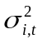are variances whose computation is explained below. The predicted indices are obtained as the summation of stock sizes, times an input index selectivity, u, over all ages:

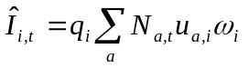 (?)
where ω indicates some input control as to whether the index is in numbers or biomass (in which case the product being summed includes weights at age), and whether computations are for the start or middle of the year. The parameters q_{i} scale each index to absolute population numbers (or biomass) and their maximum likelihood values can be obtained analytically by setting the derivative of equation (8) with respect to q_{i} equal to zero, and solving for the q_{i}.

There are several options for handling the variances, . If all the values for all indices are given equal weight, they can be set to

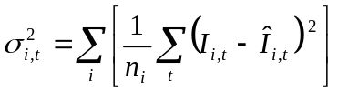
(?)
or, if all values within an index are to have equal weights but each index is weighted depending on how it is fitted by the model (maximum likelihood weighting) then:

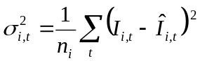. (?)

Alternatively, the variances could be input for each value, based on external information.

The parameters q_{i} and can be obtained indirectly or externally.

